Table of Contents

(focus on lit review, rm 1.1 section?)

1 Chapter 3 – The Bane of the “Inverse” Problem 1

1.1 Overview of classical and quantum inverse problems 1

1.1.1 Classical inverse problems 1

1.1.2 Quantum mechanical inverse problems 2

1.2 Workarounds to the “inverse” problem 3

1.2.1 Repeat the forward problem 3

1.2.2 Bayesian approach 4

1.2.3 Linear Combination Fitting (LCF) to references 5

1.2.4 Machine Learning 7

1.3 Inverse problem for EXAFS 8

1.3.1 Sources of information loss in EXAFS 8

1.3.2 Steps taken in EXAFS analysis to combat inverse problem 9

1.4 Inverse problem for XANES 9

1.4.1 Sources of information loss in XANES 9

1.4.2 Steps taken to combat the inverse problem in XANES 10

1.5 References 10

# Chapter 3 – The Bane of the “Inverse” Problem

In science, an “inverse” problem is using observations to try to calculate the factors that caused them. This idea is distinct from the forward problem, which starts from causes and then calculates the effects. Inverse problems are often termed “ill-posed”, which means they either (1) don’t have a solution, (2) the solution is not unique, or (3) the solution’s behavior does not change continuously with the initial conditions. In X-ray spectroscopy, the “inverse” problem – going from spectra to structure – often runs into problems with both (2) and (3). In this chapter, I will give some examples of inverse problems (both in classical and quantum mechanics), I will discuss some work arounds people have used to combat the “ill-posed” aspect of inverse problems, and then will discuss these applications and their limitations and uses for both XAFS (EXAFS and XANES) and XES spectra.

## Overview of classical and quantum inverse problems

### Classical inverse problems

One example of a classical inverse problem is the question whether you can hear the shape of the drum.

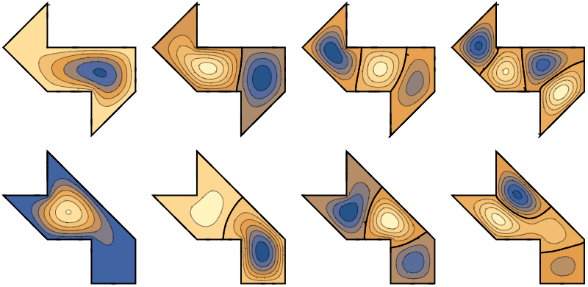

Fig. 1 Can you hear the shape of a drum? This question is one example of a classical inverse problem.

In addition to source reconstruction from acoustics, calculating the density of the Earth from measurements of its gravity field and reconstructing a three-dimensional object from its two-dimensional shadows are other examples of classical inverse problems.

### Quantum mechanical inverse problems

Some examples of quantum mechanical inverse problems are determining which arrangement of atoms yield the observed macroscopic properties or finding the potential that generates a particular spectrum. Unsurprisingly, X-ray spectroscopy is included in the list of quantum mechanical inverse problems.

## Workarounds to the “inverse” problem

Because there is no proper solution to the “inverse” problem, as there is not a well-defined problem to fix, people have used various work arounds. All these work arounds rely on some amount of prior knowledge of the system. Thus, they turn the inverse problem into an informed inverse problem, making it possible to find a solution.

### Repeat the forward problem

One way to work around the forward problem is to repeatedly perform the forward problem, each time changing the input structure. One can then adjust the input structures depending on the output, which is often theoretically calculated spectra. This process is often how theorists change parameters in their calculations to improve their theoretically calculated spectra and thus match theory and experiment. However, repeating the forward problem is very time intensive, especially when calculation-intensive theories like density functional theory (DFT), or there is a large uncertainty in the possible input structure and thus a large parameter space must be explored.

Fig. X An example of repeatedly solving the forward problem via theoretical calculations of Ru L3 edge XANES spectra of a series of Ru(II) and Ru(III) complexes. Taken from Nascimento and Govind. [Nascimento and Govind, 2022]

### Bayesian approach

Another work around is using formal Bayesian statistics to estimate the inverse problem. Although this process has been shown to work, it has not gained any traction in the community because it is very involved; not only is it very inaccessible, but it is computationally and experimentally intensive. Moreover, it also involves formalizing prior knowledge of the system by formalizing a prior in Bayes rule.

Fig. X Taken from Krappe and Rossner. [Krappe and Rossner, 2009]

[Krappe and Rossner, 2002; Krappe and Rossner, 2009; Rehr, 2005; Rossner, 2006]

### Linear Combination Fitting (LCF) to references

The most common method is linear combination fitting onto reference spectra. This approach assumes that because XAS is an average bulk probe, any components of different structures will contribute directly proportion to their concentration, or percentage of makeup. For example, an experimental sample with 2/3 the iron atoms in a 2+ oxidation state and the other 1/3 of the iron atoms in a 3+ oxidation state will result in a spectrum composed of two parts of an iron 2+ oxidation state reference and one part of an iron 3+ oxidation state reference. Obviously, things can get complicate quickly with the more properties and unknown parameters one must control for. Furthermore, choosing an appropriate library, or reference set, is critical in that it must find a balance between spanning a large enough domain to cover the experimental space but also not have redundant or correlated spectra. This issue becomes especially problematic with the highest uncertainty, or littlest prior knowledge, of the system.

Finally, this method propagates any errors, especially when fitting to theoretical spectra. It can also propagate any systematic errors in the experiment or normalization. It is especially unreliable if all your reference compounds have different second or third coordination shells, which is often the case for solution studies where reference compounds are usually crystalline.

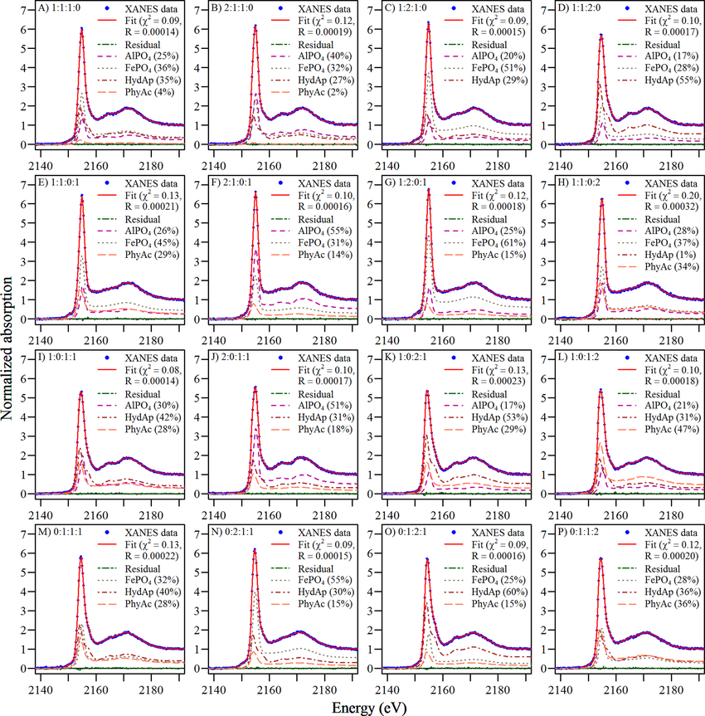

Fig. X Linear combination fitting to phosphorus XANES spectra. Taken form Werner and Prietzel. [Werner and Prietzel, 2015]

### Machine Learning

Cite Nascimento and Govind, 2022 on TD-DFT providing good enough training data for ML studies

## Inverse problem for EXAFS

### Sources of information loss in EXAFS

Because EXAFS involves taking the Fourier transform, the loss of phase information is a particularly prominent issue in EXAFS analysis. Moreover, both thermal and structural disorder in structure can cause broadening in EXAFS data, both of which are encompassed in the Debye-Waller factor in the EXAFS equation.

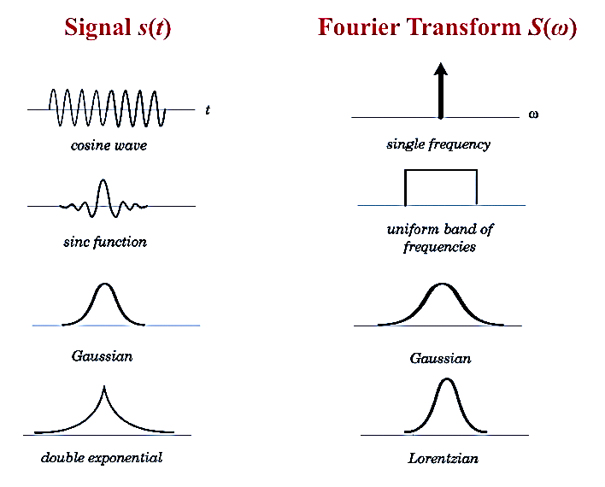

Fig. X Fourier transform pairs of certain signals.

### Steps taken in EXAFS analysis to combat inverse problem

EXAFS analysis is about incorporating more and more prior information into every step. First, you need to know the element you are probing and then the elemental make-up of the first coordination shell.

## Inverse problem for XANES

### Sources of information loss in XANES

Information is lost in XANES spectra partly due to the Heisenberg uncertainty principle, which states that you cannot know exactly both momentum and position, or energy and time in the case of X-ray spectra. Because excited states have inherent lifetimes, electronic transitions are broadened in energy. Moreover, limits on experiment apparatuses, such as the resolution of your monochromator, have inherent resolution. Thus, any transition too close in energy will be smoothed out and indistinguishable from each other. Other types of spectral broadening can occur from more classical phenomena, such as plasmons and thermal vibrations.

Another reason why obtaining chemical or geometrical properties directly from spectra is difficult is because of correlated spectra, meaning the two different chemical properties can cause the same spectral feature. Or effects on spectra can be in overlapping energy regions, making it impossible to discern the cause of the feature. [Jahrman, 2022]

### Steps taken to combat the inverse problem in XANES

All four of the previously stated work arounds for the inverse problem (repeat the forward problem, Bayesian analysis, compare to a reference, and machine learning) have been applied to XANES spectra.

## References